Honey-The Good, the Bad, and the Ugly

A topic that we would do well to discuss is honey! While I recommend honey as one of the few acceptable sweeteners on this eating program, the sad truth is, not all honey is created equal. In fact, honey is the third-most adulterated food in the world¹. Let’s discuss what’s out there and how to avoid the pitfalls of consuming subpar (or potentially dangerous) honey imposters.
It is vitally important to exercise discretion when purchasing your honey at the supermarket. A recent analysis in Australia², one of the world’s largest exporters of honey, tested 28 samples of honey and found almost half of them to be adulterated in some way. Specifically, 12 of the 28 honey samples were found to have been diluted with cheap sweeteners, such as wheat syrup, rice syrup, or sugar beet syrup. The most commonly contaminated brands were those containing foreign honey, most often from China.
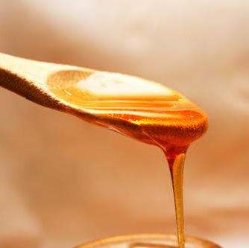
What does this mean for honey sold in the United States? To quote the magic 8 ball, “Outlook not so good.” While Australia has a standard for testing honey, the United States does not. In fact, a lab analysis conducted in 2011³ found that 76% of honey sold in the United States had no pollen in it, indicating that the “honey” is not at all what it appears. To remove pollen from honey is an expensive process, and there is only one reason to do it, so why would the majority of honey producers do it? According to food scientists and honey specialists, pollen is the only way to definitively pinpoint the source or origin of honey. To quote Richard Adee, a national producer of high-quality, raw honey, “It’s no secret to anyone in the business that the only reason all the pollen is filtered out [of honey] is to hide where it initially came from and the fact is that in almost all cases, that is China.” Why do so many companies want to illegally source their honey from China? Because it’s cheap. But there’s a problem with all this. Honey from China is potentially dangerous, as it can contain illegal antibiotics, pesticides, and heavy metals. Furthermore, this “honey” is also frequently diluted with cheap sugar. What is remains in the final product is a mix of cheap sugar syrups such as malt sweeteners, sugar water, corn or rice syrups, and a little bit of actual honey⁴. What does this mean for you, the consumer? Unfortunately, it means that the “healthy” product you thought you were buying is nothing more than glamorized, overpriced, and unhealthy sugary syrup that has been made to look and taste like honey. This eating program is all about restoring health and reversing dis-ease, so I highly recommend avoiding this imposter honey at all costs. Here are some details from the study that will help you make informed decisions when selecting honey at your next grocery store visit:
- 76% of honey sampled from grocery stores had all the pollen removed. These grocery stores included large chains, such as Kroger, Safeway, Giant Eagle, TOP Food, QFC, and more.
  - Specific brands that had all the pollen removed included:
    - Sue Bee Brands
    - Clover Maid
    - Aunt Sue
    - Natural Pure
    - Most store/generic brands
  - Honey labelled as organic was more likely to contain pollen, as 71% of these honey samples did contain pollen.
- 77% of honey sampled from big box stores (such as Walmart, Costco, Sam’s club, H-E-B, and Target) did not contain pollen
- 100% of honey sampled from drugstores (i.e., Walgreens, CVS, & Rite-Aid) had no pollen
- 100% of honey packaged in small, individuals packets (from such places as McDonald’s & KFC) had the pollen removed
- 100% of honey sampled from farmer’s markets, co-ops, and “natural” stores, such as Trader Joe’s, had the full, anticipated amount of pollen
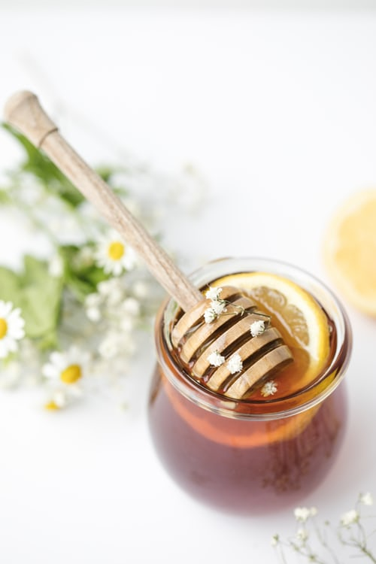
So what is our takeaway from all this mess? You best bet for buying pure, raw, completely natural honey is to buy it from 1. Farmer’s Makets 2. Co-ops 3. Natural health food stores 4. Organic brands from the grocery stores. Here are some tips to keep in mind when choosing your honey:

- If the honey seems unreasonably cheap, it is probably counterfeit.
- Look at the honey—is it clear or cloudy? If the honey is perfectly clear, it probably has been ultra-filtered and adulterated to remove the pollen. Not only does ultra-filtration remove the pollen, but it removes a great deal of the health-promoting nutrients inside the honey, such as its minerals, vitamins, proteins, fatty acids, and amino acids. Meanwhile, if the honey is cloudy and labelled and raw and unfiltered, it is a safe bet that it probably the real deal.
- Honey that crystallizes or solidifies is usually real honey.
- The best honey you can buy is raw, unfiltered, and from wild flowers.

References:
- Zhou, X., Taylor, M. P., Salouros, H., & Prasad, S. (2018). Authenticity and geographic origin of global honeys determined using carbon isotope ratios and trace elements. Scientific reports, 8(1), 14639.
- Ferguson, A., Gillett, C., & Fairfax Media. (2018, September 3). 'It's just sugar syrup': Supermarkets accused of selling 'fake' honey. Retrieved December 6, 2019, from https://www.abc.net.au/news/2018-09-03/capilano-and-supermarkets-accused-of-selling-fake-honey/10187628.
- Petersen, S., & Bryant, V. (2011). The study of pollen and its role in the honey market. American Bee Journal, 151(6), 591.
- Laskawy, T. (2019). Honey laundering: tainted and counterfeit Chinese honey floods into the U.S. Retrieved 6 December 2019, from https://grist.org/food-safety/2011-08-18-honey-laundering-tainted-counterfeit-from-china-in-us/

